**web guide**

**Microsoft Office User**

Ryan Sports Club **| nairobi kenya**

ryan sports club

Table of Contents

ACKNOWLEDGEMENT 2

SYNOPSIS & PROJECT ANALYSIS 3

DIAGRAMS 4

DATA FLOW DIAGRAMS LEVEL – 0 AND LEVEL-1. 4

LEVEL- 0. 4

DFD Level-1 5

FLOWCHART DIAGRAM 6

PROCESS DIAGRAM 8

USER’s GUIDE 9

Navigation bar 10

PAGES 11

Gallery 12

Membership Form Page 14

Send message form 18

DEVELOPERS GUIDE 32

Index html code 32

Index html style css 36

Form page html 50

Form page style css 52

Gallery page html 55

Email html 57

Email css 58

Script file 59

# ACKNOWLEDGEMENT

With immense please I, Mr Hermon Tsegay designing this website for Ryan sport club wish to thank all the Edulink staff who gave me unending support.

I express my profound thanks to Mr. Keneth Mathiu for his advice and guidance and all these who have indirectly did so too in preparation of this website.

**Student name : HERMON TSEGAY OQUBALDET ID NO : STUDENT 2109759**

## SYNOPSIS & PROJECT ANALYSIS

Ryan sports club is a website that deals with a gym activity company. This website introduces a user with

the best gym provider which is holding a lead in the effect of social gym participation in the world.

My website enables users to watch and explore different sport activity available at the sports club.

It also enables them enroll online for their favorite sport kind.

This website also holds different features like galleries and google location of the sports club.

My website has ensured the details of each available devices for esteemed customers who access

my website.

### DIAGRAMS

### 

### DATA FLOW DIAGRAMS LEVEL – 0 AND LEVEL-1.

#### LEVEL- 0.

login update

Customer

manager

website

confirmation confirmation

### DFD Level-1

Register

online

1.

Customer

Payment mode

register

Acknowledgement customer and registry information

2.

Manager

Customer data store

Register information

Register information

Ryan sports club

Register device

3.

Confirmation

mail

### FLOWCHART DIAGRAM

Want to see all service classes

Look in to image link

Look all the classes

YES

No

Browse service class

Found suitable service class

Search for another service class

No

Yes

Search for chosen service class

Look for class feature and price

B

B

Found class suitable to register

Look for another class

No

Yes

Enter email to register online

Press enter email

### PROCESS DIAGRAM

ANALYSIS PHASE DESIGN PHASE DEPLOYMENT

HTML DESIGNS

WEBSITE MANUAL

INTRODUCTORY DISCUSSIONS

CSS DESIGN

DEPLOY WEBSITE TO USERS

REQUIRMENT ANALYSIS

JAVA SCRIPT

PROPOSAL

PRESENT HOW THE WEBSITE OPERATES

No Yes No Yes

CLIENT AGREES

AGREE ON SCHENDULE

FILLING DATA TO WEBSITE

FULL DATA OUT LINE OF WEBSITE DIAGRAM

#### USER’s GUIDE

At first I designed the *index* page in a way that I want so that I could use the same features for the home page, the about us page, the classes page, the contact page. The index page has pages for different services given by the website. Some of the pages include the home page, the about us page, classes page, contact page. The code for the index html is as follows.

#### Navigation bar

This is how the header page looks like. It consists of a logo in the name of the website and it’s different categories and the navigation to the home, about us page, classes page and contact page.

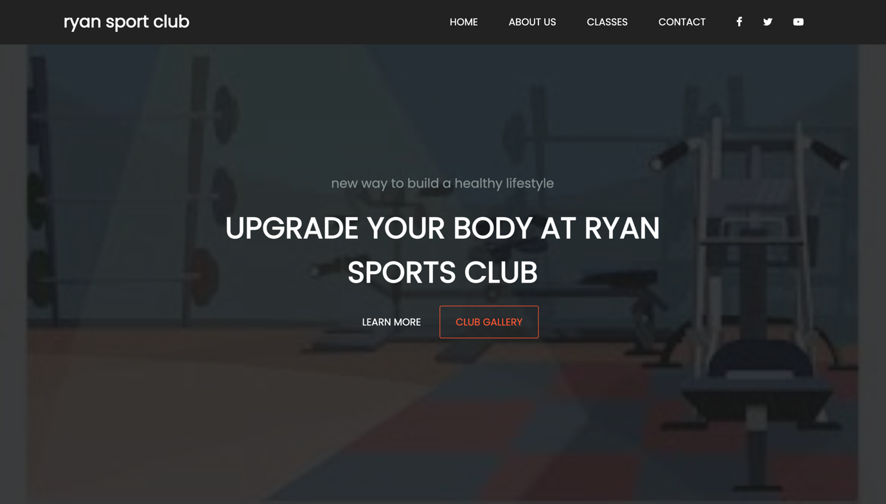

#### PAGES

The homepage

The home page is meant to contain contents for the navigation link, the logo, the image link and gallery link. It has the header section with the logo and navigation bar, the part of the body that is created with suitable sections except the footer and the footer that has copyright and the Facebook , twitter as well the Instagram contact. This is how it looks like;



#### Gallery

This is the gallery page.

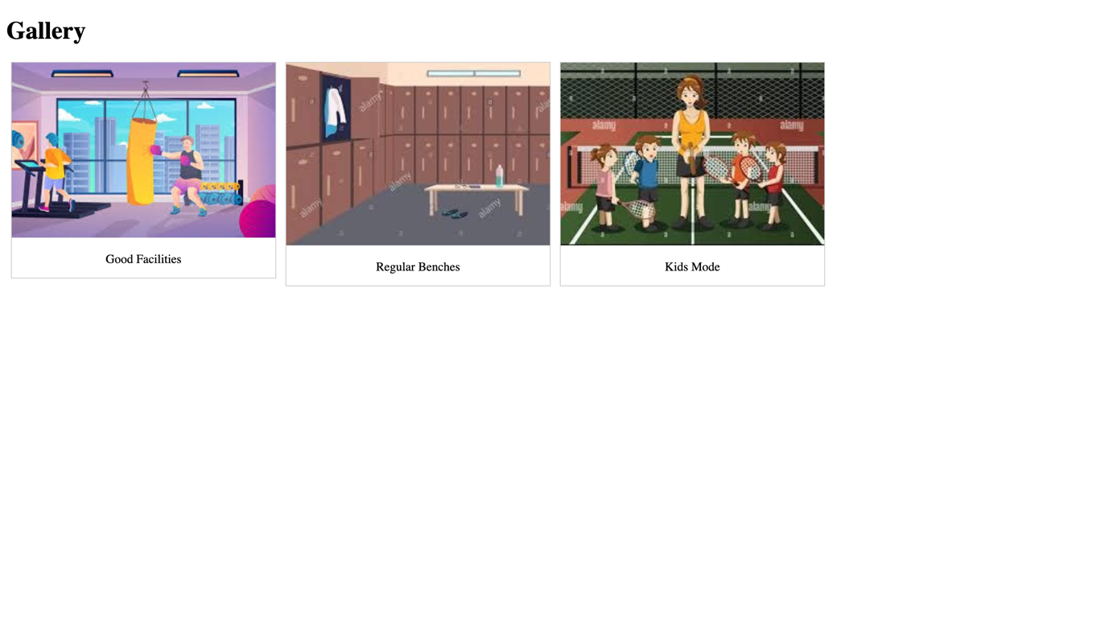

Membership Link page

This a page where it contains the working hours schedule and the link to registration form.

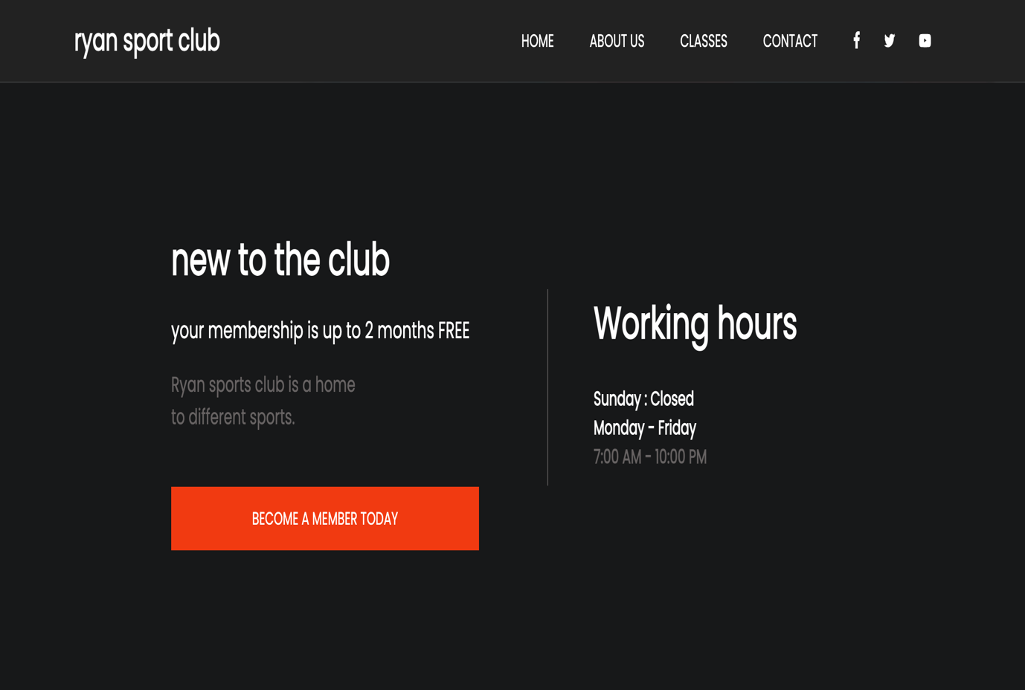

#### Membership Form Page

This is the page where you register.

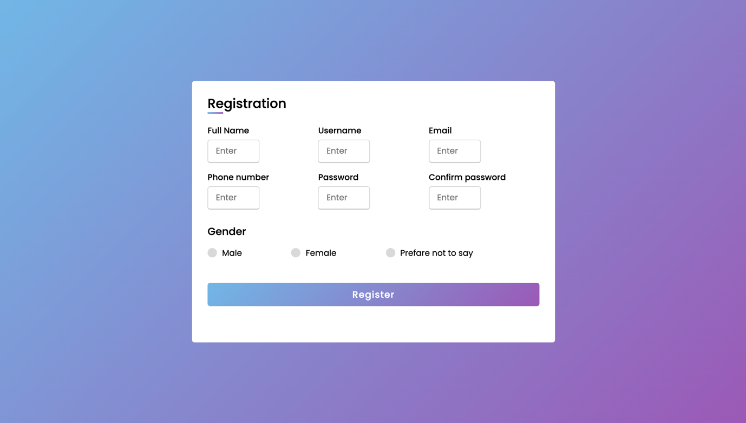

About Us

This is the page where you get information about the club overall.

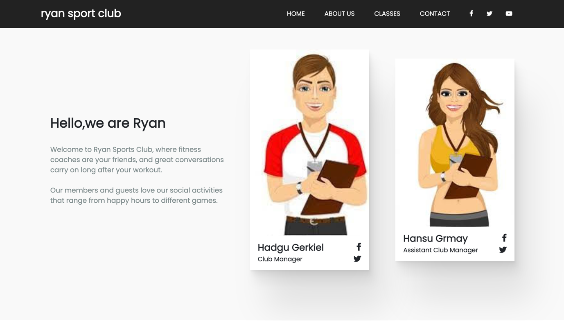

Classes (Services) Page

This is the page where you discover the services of the club.

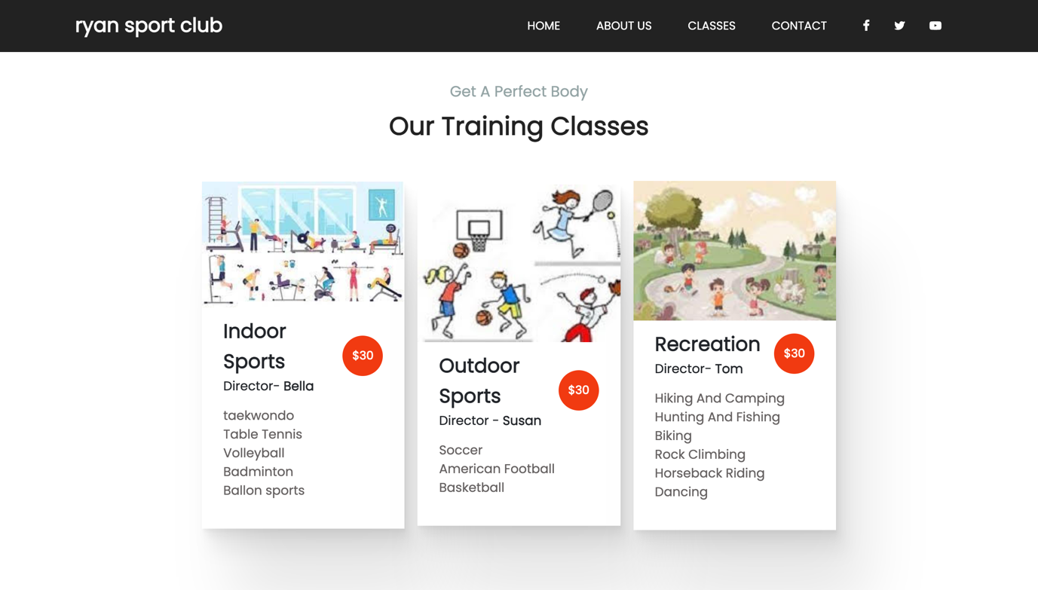

Contact Us Page

The contact page contains the location of the Ryan sports club and the send message link which when clicked takes you to a dump form .

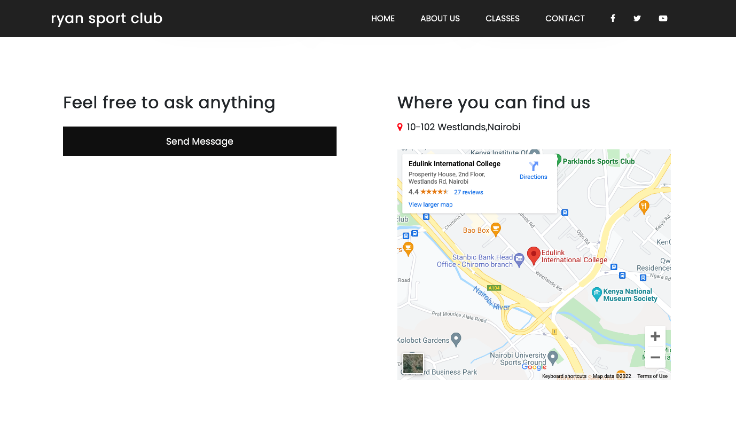

#### Send message form

This is the page where you send your message.

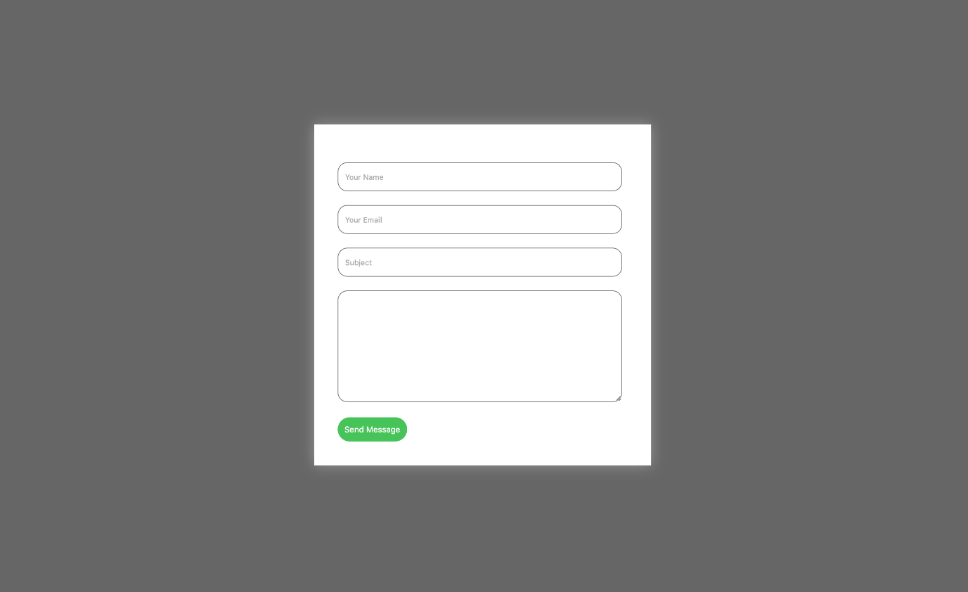

The Footer

The footer has two social media links and the copy right for the website.



***This is how the pages look like in tablet form.***

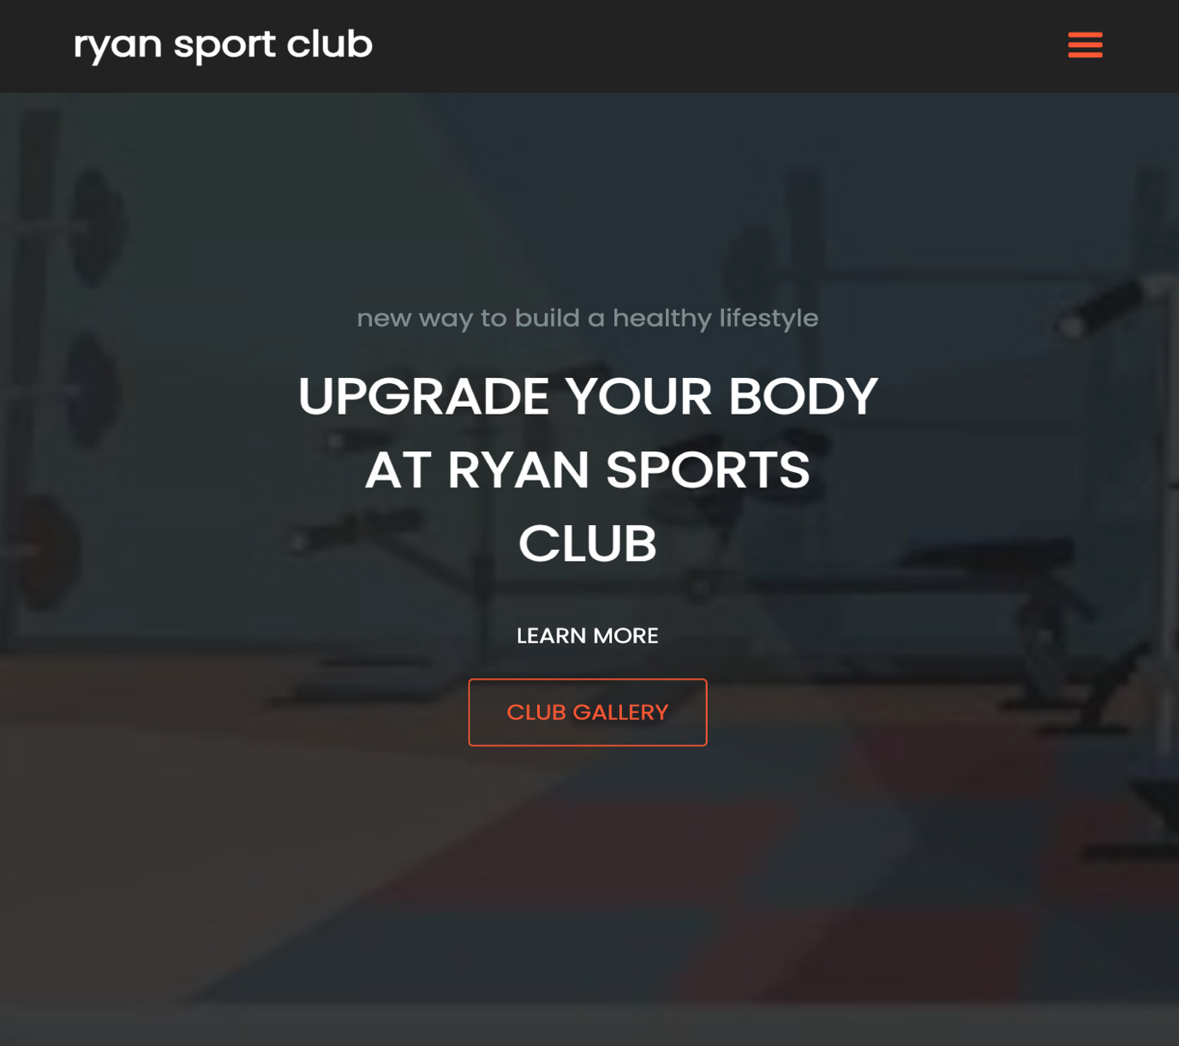

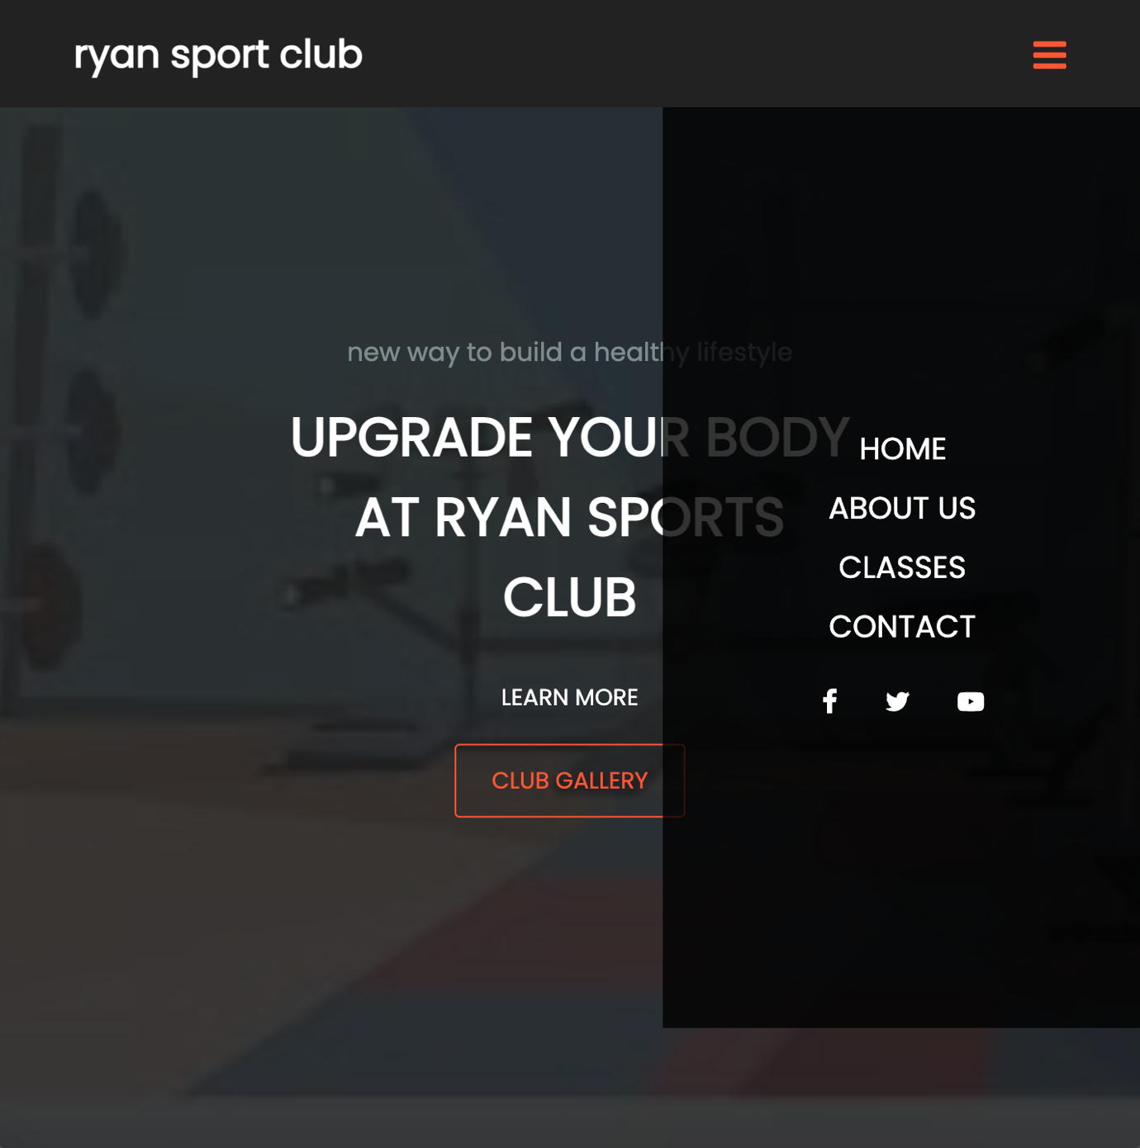

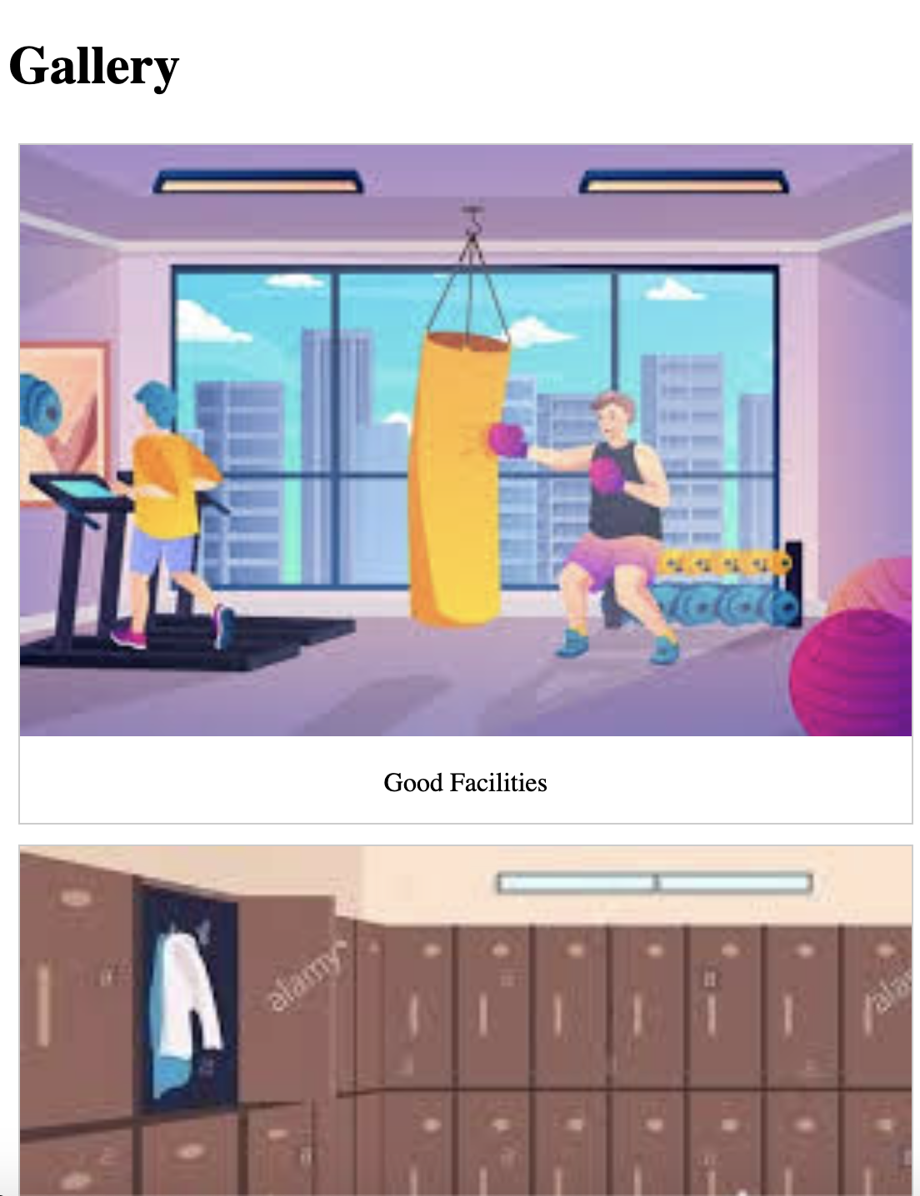

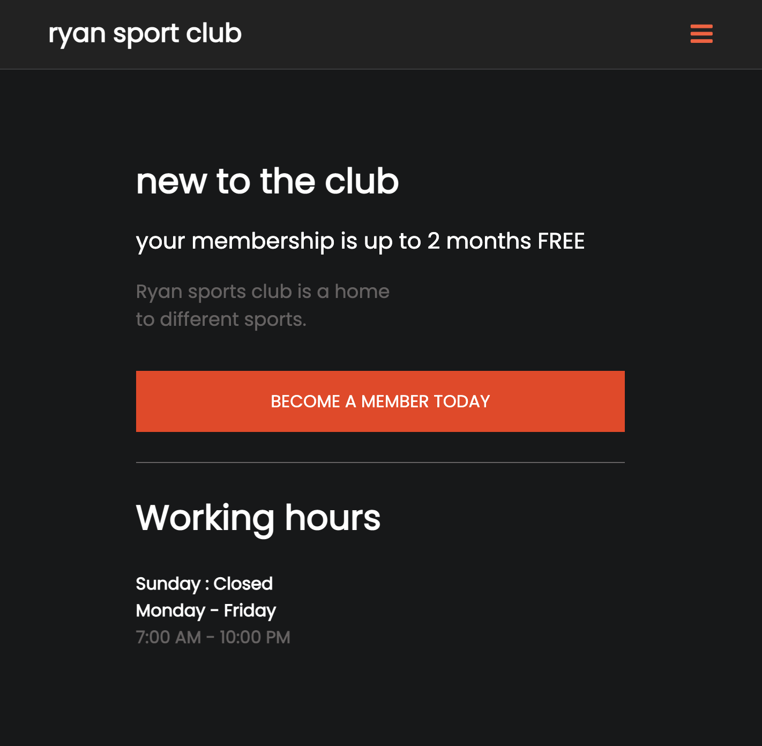

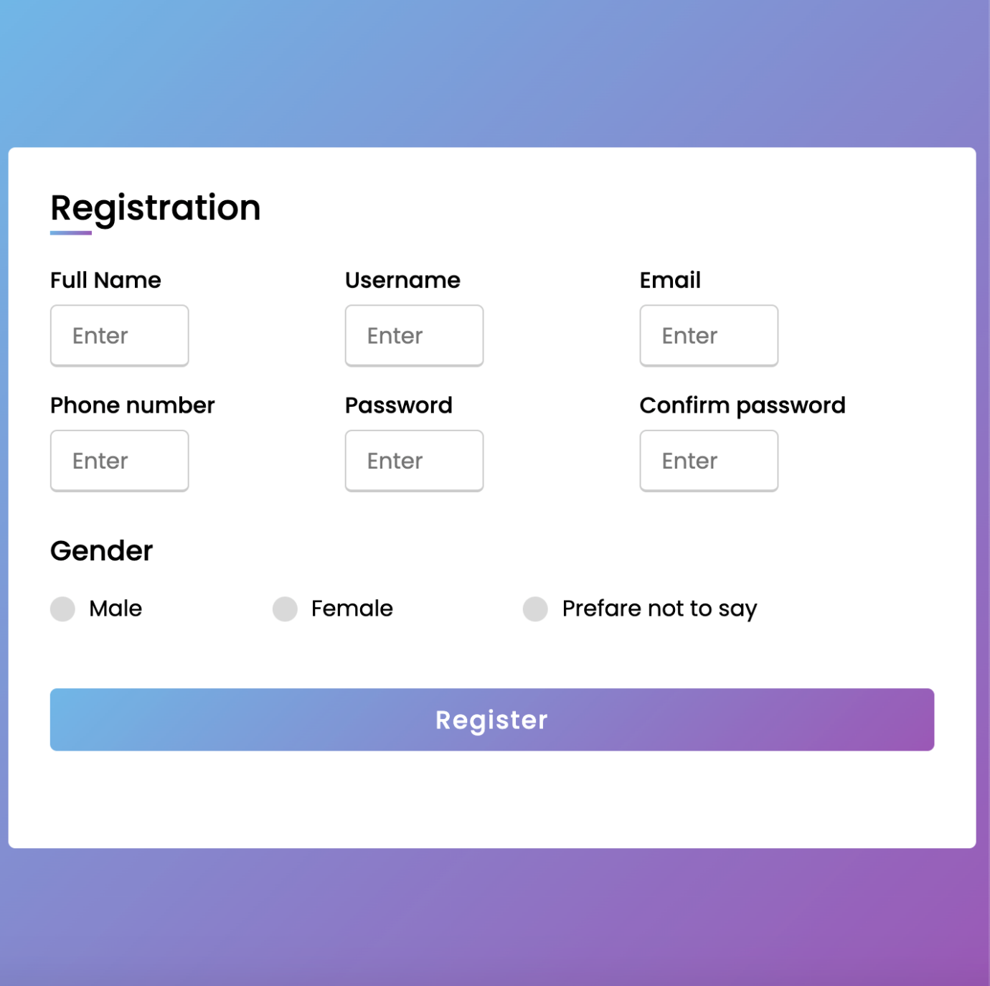

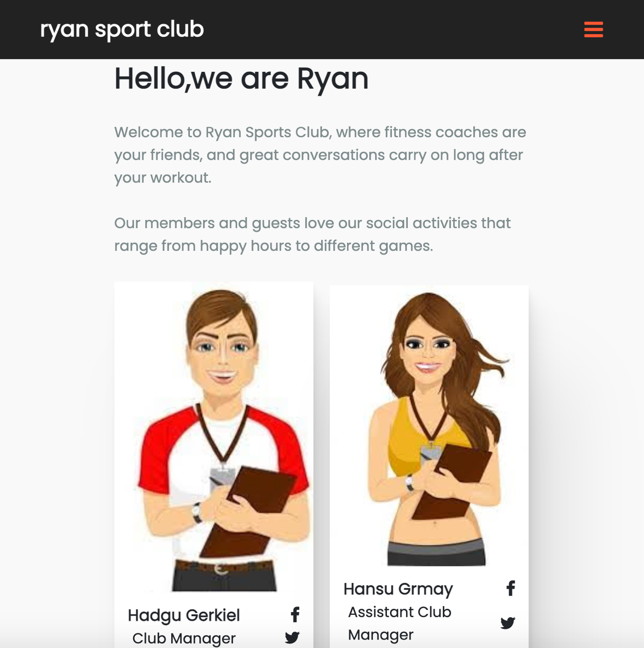

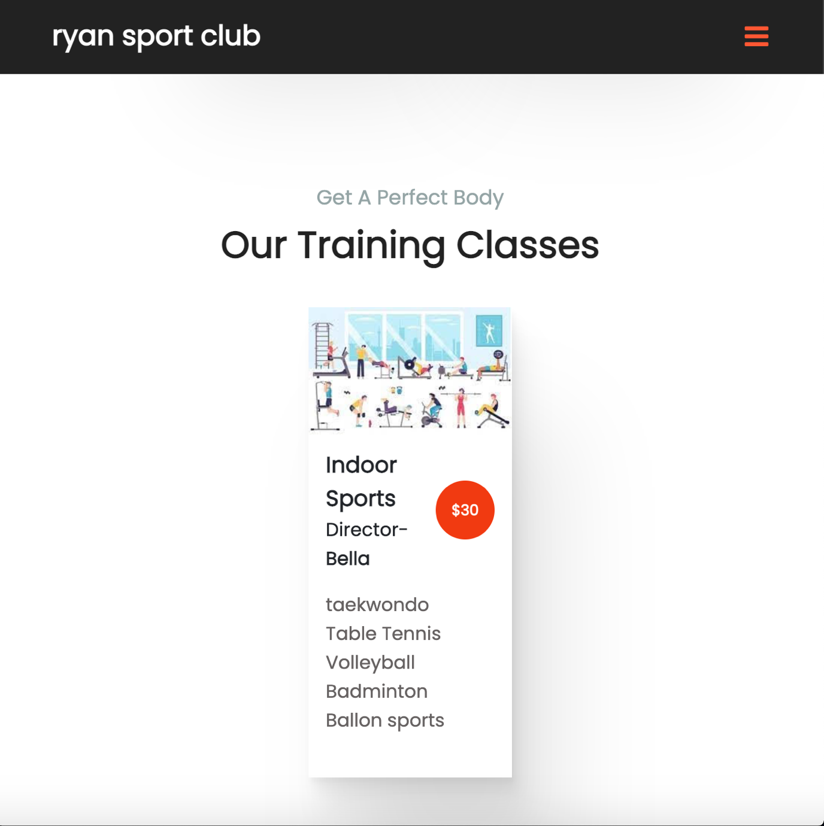

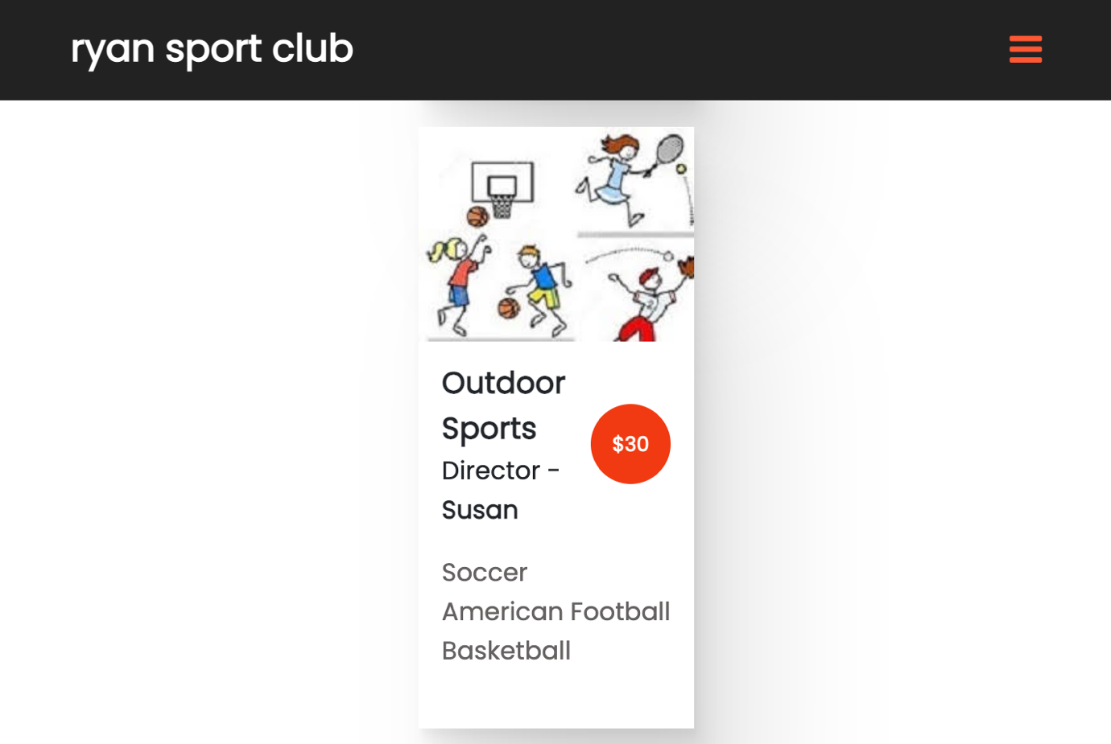

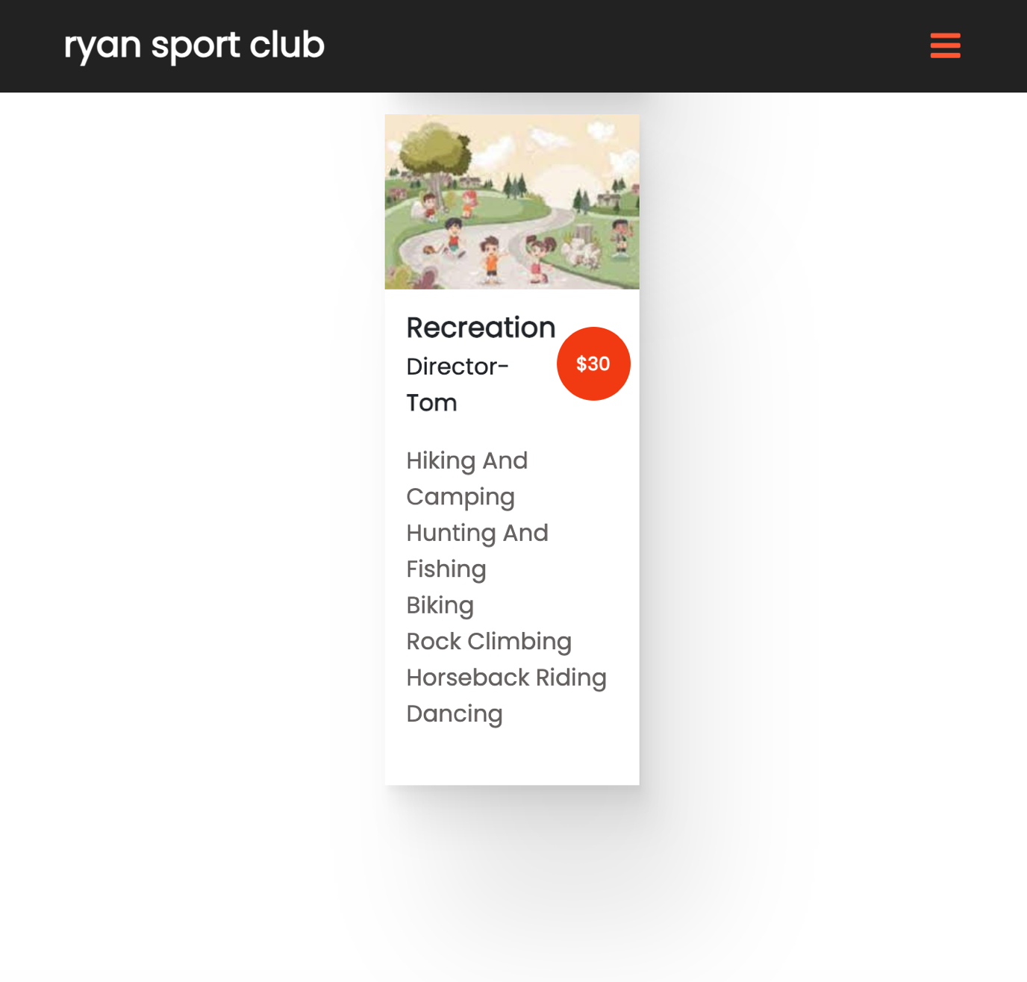

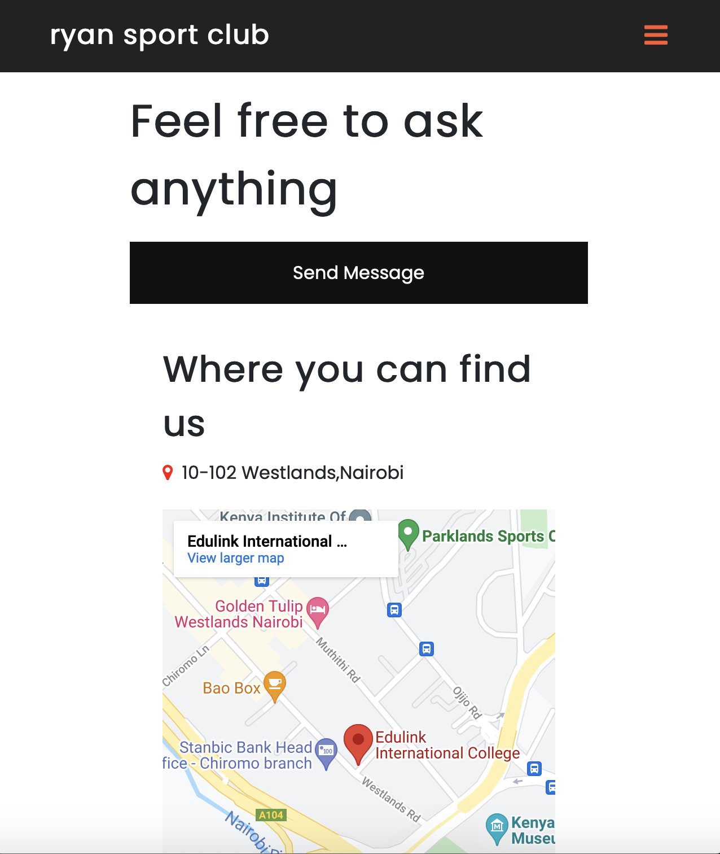

*Send message form*

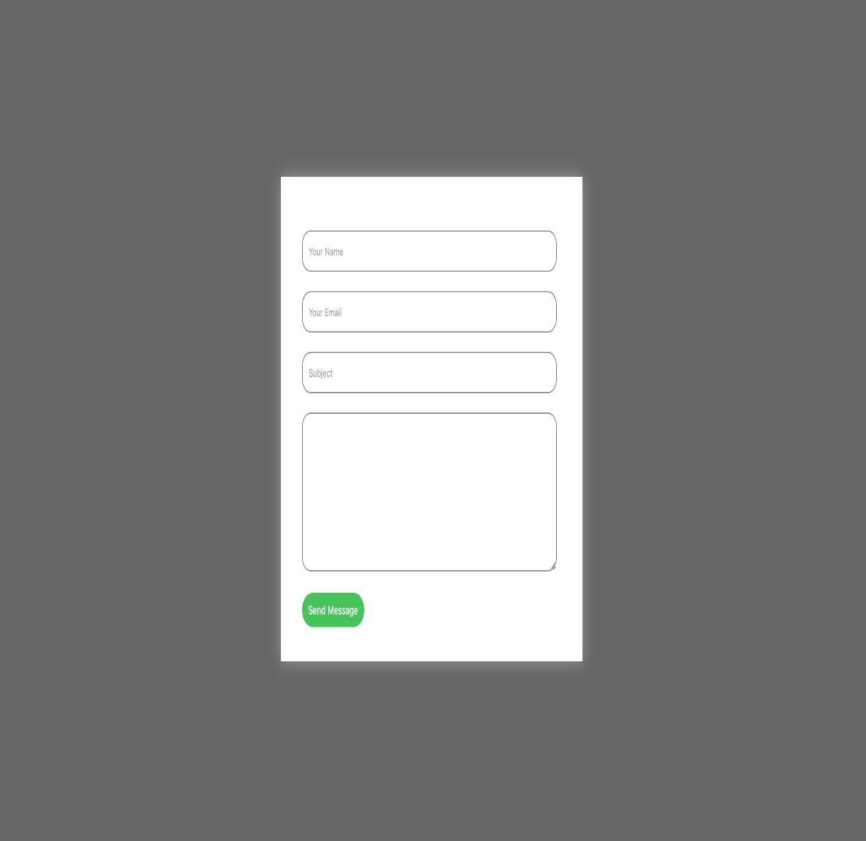

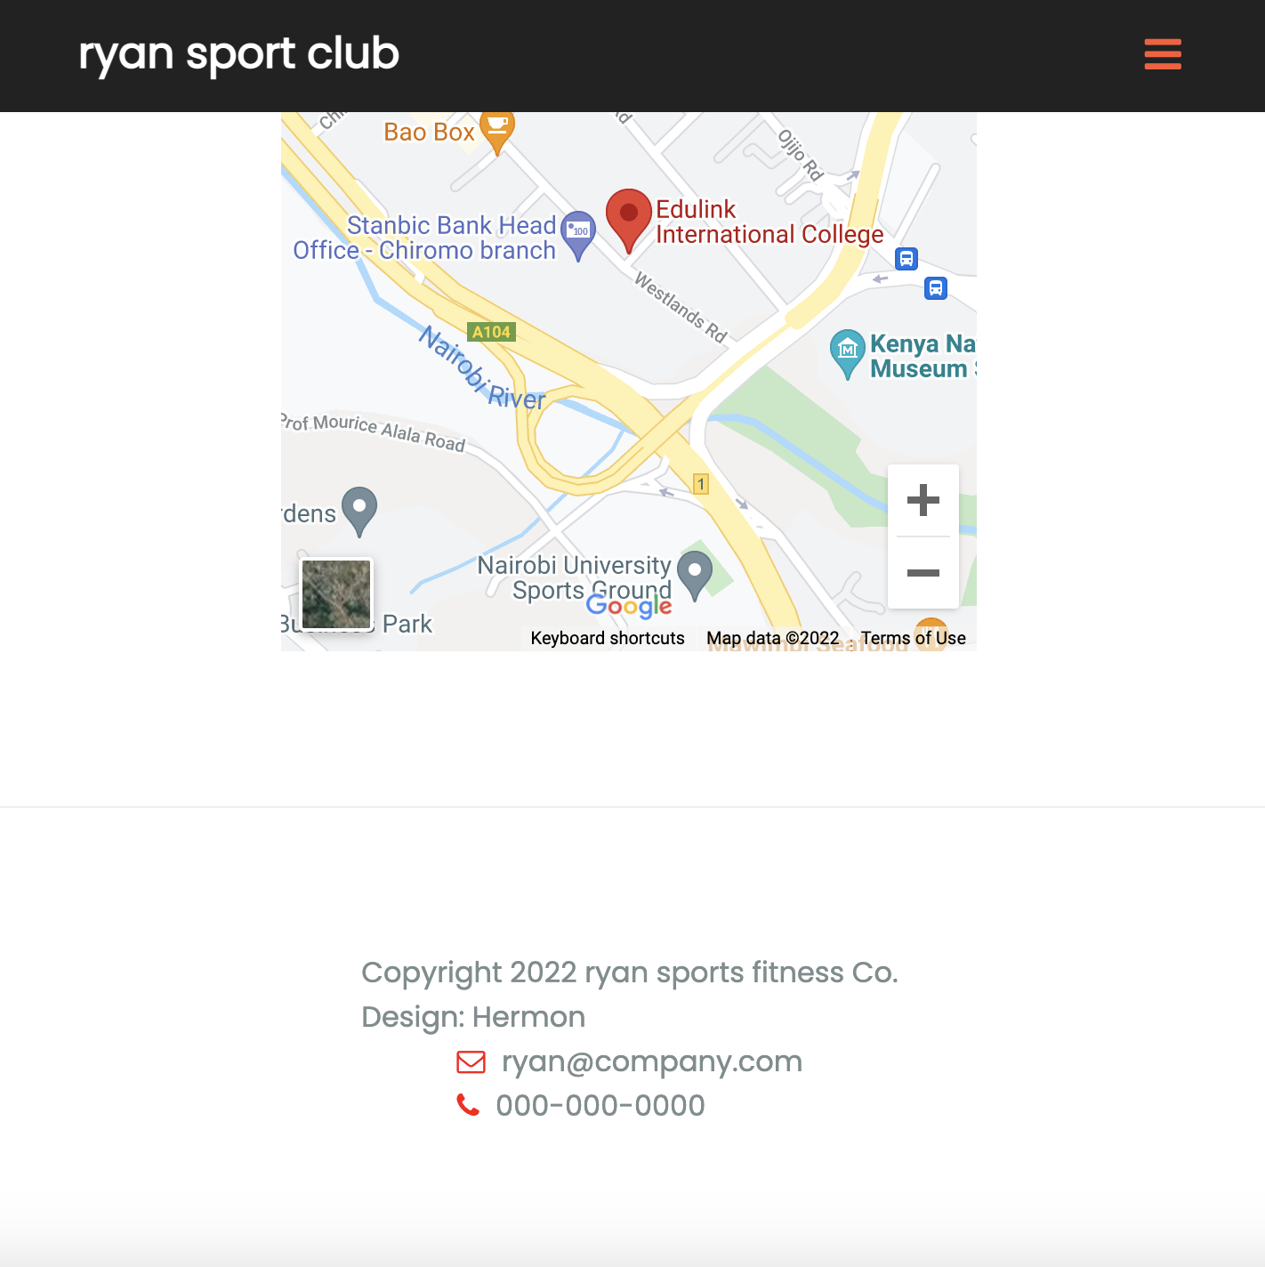

##### DEVELOPERS GUIDE

##### Index html code

<!DOCTYPE html>

<html lang="en">

<head>

<title>ryan sports club</title>

<link href="https://maxcdn.bootstrapcdn.com/font-awesome/4.7.0/css/font-awesome.min.css" rel="stylesheet" integrity="sha384-wvfXpqpZZVQGK6TAh5PVlGOfQNHSoD2xbE+QkPxCAFlNEevoEH3Sl0sibVcOQVnN" crossorigin="anonymous">

<link rel="stylesheet" href="https://unpkg.com/aos@next/dist/aos.css"/>

<link rel="stylesheet" type="text/css" href="style/style.css">

</head>

<body>

<div class="nav">

<h2>ryan sport club</h2>

<ul id="item">

<li><a href="#home">Home</a></li>

<li><a href="#about">About Us</a></li>

<li><a href="#classes">Classes</a></li>

<li><a href="#contact">Contact</a></li>

<div class="icon">

<i class="fa fa-facebook" aria-hidden="true"></i>

<i class="fa fa-twitter" aria-hidden="true"></i>

<i class="fa fa-youtube-play" aria-hidden="true"></i>

</div>

</ul>

<i id="bar" class="fa fa-bars" aria-hidden="true"></i>

</div>

<div id="home" class="back">

<div class="overlay"></div>

</div>

<div class="mid">

<p>new way to build a healthy lifestyle</p>

<h2>UPGRADE YOUR BODY AT RYAN SPORTS CLUB</h2>

<div class="btn">

<a class="simple" href="#">learn more</a>

<a class="border" href="gallery/gallery.html">club Gallery</a>

</div>

</div>

<div class="details">

<div class="one" data-aos="fade-up">

<h3>new to the club</h3>

<h6>your membership is up to 2 months FREE</h6>

<p>Ryan sports club is a home<br>to different sports.</p>

<a href="form/form.html">Become a member today</a>

</div>

<div class="two" data-aos="fade-up">

<h3>Working hours</h3>

<br>

<h5>Sunday : Closed</h5>

<h5>Monday - Friday<h5>

<p>7:00 AM - 10:00 PM</p>

</div>

</div>

<div id="about" class="trainer">

<div class="about">

<h2 data-aos="fade-up">Hello,we are Ryan</h2>

<p data-aos="fade-up">Welcome to Ryan Sports Club, where fitness coaches are your friends, and great conversations carry on long after your workout.

<br>

<br>

Our members and guests love our social activities that range from happy hours to different games.

</p>

</div>

<div class="people" data-aos="fade-up">

<div class="team1">

<div class="img">

<img src="img/c.jpg">

</div>

<div class="teamDetails">

<div class="name">

<h4>Hadgu Gerkiel</h4>

<i class="fa fa-facebook" aria-hidden="true"></i>

</div>

<div class="pro">

<p>Club Manager</p>

<i class="fa fa-twitter" aria-hidden="true"></i>

</div>

</div>

</div>

<div class="team1">

<div class="img">

<img src="img/d.jpg">

</div>

<div class="teamDetails">

<div class="name">

<h4>Hansu Grmay</h4>

<i class="fa fa-facebook" aria-hidden="true"></i>

</div>

<div class="pro">

<p>Assistant Club Manager</p>

<i class="fa fa-twitter" aria-hidden="true"></i>

</div>

</div>

</div>

</div>

</div>

<div id="classes" class="class">

<p class="paragraph" data-aos="fade-up">Get A Perfect Body</p>

<h2 class="h2" data-aos="fade-up">Our Training Classes</h2>

<div class="classMenu">

<div class="team1" data-aos="fade-up">

<div class="img">

<img src="img/j.jpg">

</div>

<div class="teamDetails">

<div class="name">

<div class="nameDetails">

<h4>Indoor Sports</h4>

<p>Director- <span>Bella</span></p>

</div>

<div class="num">

<h5>$30</h5>

</div>

</div>

<div class="pro">

<p>taekwondo<br>Table Tennis<br>Volleyball<br>Badminton<br>Ballon sports</p>

</div>

</div>

</div>

<div class="team1" data-aos="fade-up">

<div class="img">

<img src="img/k.jpg">

</div>

<div class="teamDetails">

<div class="name">

<div class="nameDetails">

<h4>Outdoor Sports</h4>

<p>Director - <span>Susan</span></p>

</div>

<div class="num">

<h5>$30</h5>

</div>

</div>

<div class="pro">

<p>Soccer<br>American Football<br>Basketball</p>

</div>

</div>

</div>

<div class="team1" data-aos="fade-up">

<div class="img">

<img src="img/m.jpg">

</div>

<div class="teamDetails">

<div class="name">

<div class="nameDetails">

<h4>Recreation</h4>

<p>Director- <span>Tom</span></p>

</div>

<div class="num">

<h5>$30</h5>

</div>

</div>

<div class="pro">

<p>Hiking And Camping<br>Hunting And Fishing<br>Biking<br>Rock Climbing<br>Horseback Riding<br>Dancing</p>

</div>

</div>

</div>

</div>

</div>

<div id="contact" class="contact">

<div class="form">

<h2 data-aos="fade-up">Feel free to ask anything</h2>

<div class="submit" data-aos="fade-up">

<a href="email/email.html">Send Message</a>

</div>

</div>

<div class="map" data-aos="fade-up">

<h2>Where you can find us</h2>

<p><i class="fa fa-map-marker" aria-hidden="true"></i>

10-102 Westlands,Nairobi</p>

<iframe src="https://www.google.com/maps/embed?pb=!1m18!1m12!1m3!1d3988.834489491735!2d36.809596513947085!3d-1.2724191990719302!2m3!1f0!2f0!3f0!3m2!1i1024!2i768!4f13.1!3m3!1m2!1s0x182f1bac136cf441%3A0x1891bf6528de50a9!2sEdulink%20International%20College!5e0!3m2!1sen!2ske!4v1643443971462!5m2!1sen!2ske" width="600" height="450" style="border:0;" allowfullscreen="" loading="lazy"></iframe>

</div>

</div>

<div class="footer">

<p>Copyright 2022 ryan sports fitness Co.<br>Design: Hermon</p>

<p><i class="fa fa-envelope-o" aria-hidden="true"></i>

ryan@company.com<br><i class="fa fa-phone" aria-hidden="true"></i>

000-000-0000</p>

</div>

<script src="https://unpkg.com/aos@next/dist/aos.js"></script>

<script>

AOS.init({

offset: 200,

duration: 1000,

});

</script>

<script src="script/script.js"></script>

</body>

</html>

##### Index html style css

@import url('https://fonts.googleapis.com/css2?family=Open+Sans:ital,wght@0,300;0,400;0,600;0,700;0,800;1,300;1,400;1,600;1,700;1,800&family=Poppins:ital,wght@0,300;0,400;1,200;1,300&display=swap');

*{

margin: 0;

padding: 0;

box-sizing:border-box;

font-family:"Poppins",sans-serif;

}

html{

scroll-behavior: smooth;

}

.nav{

position: fixed;

display: flex;

flex-direction: row;

justify-content: space-between;

align-items: center;

width: 100%;

padding: 1rem 6.5rem;

background: #222;

z-index: 100000;

}

.nav h2{

color: #fff;

font-size: 1.7rem;

}

#item{

display: flex;

flex-direction: row;

justify-content: center;

align-items: center;

}

#item li{

list-style: none;

padding-right: 50px;

}

#item li a{

text-decoration: none;

font-size: 1rem;

text-transform: uppercase;

color: #fff;

}

#item li a:hover, #item .icon i:hover{

color: #ff5733;

cursor: pointer;

}

#item .icon i{

color: #fff;

padding-right: 30px;

font-weight: bolder;

}

#bar{

color: #ff5733;

font-weight: lighter;

font-size: 1.5rem;

display: none;

}

.back{

background-image:url(background.jpg);

width: 100%;

height: 100vh;

background-size: cover;

z-index: -1;

}

.back .overlay{

background: #171819;

width: 100%;

height: 100%;

opacity: 0.85;

}

.mid{

position: absolute;

top: 50%;

left: 50%;

transform: translate(-50%, -50%);

text-align: center;

}

.mid p{

color: #7f8c8d;

font-size: 1.3rem;

margin-bottom: 1.4rem;

}

.mid h2{

color: #fff;

font-size: 3rem;

}

.mid .btn{

margin-top: 2rem;

}

.mid .btn a{

text-decoration: none;

text-transform: uppercase;

}

.mid .btn a.simple{

color: #fff;

font-weight: 500;

padding: 0.9rem 1.6rem;

}

.mid .btn a.simple:hover{

color: #ff5733;

}

.mid .btn a.border{

color: #ff5733;

border:1px solid #ff5733;

font-weight: 500;

padding: 0.9rem 1.6rem;

border-radius: 3px;

}

.mid .btn a.border:hover{

background: #fff;

border:1px solid #fff;

}

.details{

width: 100%;

display: flex;

flex-direction: row;

justify-content: space-between;

align-items: center;

padding: 8rem 15rem;

background: #171819;

}

.details h3,h6,h5{

color: #fff;

}

.details .one{

width: 45%;

display: flex;

flex-direction: column;

justify-content: flex-start;

}

.details .one h3{

font-size: 2.5rem;

padding-bottom: 1.1rem;

}

.details .one h6{

font-size: 1.3rem;

font-weight: 400;

padding-bottom: 1.2rem;

}

.details .one p{

color: #666262;

font-size: 1.2rem;

padding-bottom: 3rem;

}

.details .one a{

color: #fff;

background: #f13a11;

padding: 1rem 0;

text-decoration: none;

text-transform: uppercase;

text-align: center;

}

.details .one a:hover{

background: #fff;

color: #f13a11;

}

.details .two{

width: 45%;

border-left: 1px solid #666262;

padding-left: 4rem;

}

.details .two h3{

font-size: 2.5rem;

}

.details .two h5{

font-size: 1.1rem;

}

.details .two p{

font-size: 1.1rem;

color: #666262;

margin-bottom: 0.8rem;

}

.trainer{

background: #f9f9f9;

padding: 8rem;

display: flex;

flex-direction: row;

justify-content: space-between;

align-items: center;

}

.trainer .about{

width: 39%;

}

.trainer .about h2{

color: #212529;

font-size: 2.1rem;

padding-bottom: 1.8rem;

}

.trainer .about p{

color: #7f8c8d;

font-size: 1.1rem;

}

.trainer .people{

width: 57%;

display: flex;

flex-direction: row;

justify-content: space-between;

align-items: center;

}

.trainer .people .team1{

width: 45%;

height: auto;

box-sizing: border-box;

background: #fff;

box-shadow:

1.9px 4.5px 3.6px rgba(0, 0, 0, 0.031),

5.4px 12.5px 10px rgba(0, 0, 0, 0.045),

13px 30.1px 24.1px rgba(0, 0, 0, 0.059),

43px 100px 80px rgba(0, 0, 0, 0.09)

;

}

.trainer .people .team1 .img img{

width: 100%;

object-fit: cover;

}

.trainer .people .team1 .name, .trainer .people .team1 .pro{

display: flex;

flex-direction: row;

justify-content: space-between;

align-items: center;

}

.trainer .people .team1 .name{

padding: 5px 20px 0 20px;

}

.trainer .people .team1 .teamDetails{

display: flex;

flex-direction: column;

justify-content: center;

padding-bottom: 10px;

}

.trainer .people .team1 .name h4{

color: #212529;

font-size: 1.5rem;

}

.trainer .people .team1 .name i, .trainer .people .team1 .pro i{

font-size: 1.3rem;

font-weight: bolder;

cursor: pointer;

color: #212529;

}

.trainer .people .team1 .pro{

padding: 0 20px 5px 20px;

}

.trainer .people .team1 .pro p{

color: #212529;

}

.class{

display: flex;

flex-direction: column;

justify-content: center;

align-items: center;

padding: 7rem 8rem;

}

.class .paragraph{

font-size: 1.3rem;

color: #95a5a6;

padding-bottom: 6px;

text-align: center;

}

.class .h2{

font-size: 2.2rem;

color: #222;

font-weight: 700;

padding-bottom: 50px;

text-align: center;

}

.class .classMenu{

display: flex;

flex-direction: row;

justify-content: space-between;

align-items: center;

}

.class .classMenu .team1{

width: 32%;

height: auto;

box-sizing: border-box;

background: #fff;

box-shadow:

1.9px 4.5px 3.6px rgba(0, 0, 0, 0.031),

5.4px 12.5px 10px rgba(0, 0, 0, 0.045),

13px 30.1px 24.1px rgba(0, 0, 0, 0.059),

43px 100px 80px rgba(0, 0, 0, 0.09)

;

}

.class .classMenu .team1 .img img{

width: 100%;

object-fit: cover;

}

.class .classMenu .team1 .teamDetails{

display: flex;

flex-direction: column;

justify-content: center;

padding-bottom: 10px;

}

.class .classMenu .team1 .teamDetails .name{

display: flex;

flex-direction: row;

justify-content: space-between;

align-items: center;

padding: 5px 30px 0 30px;

}

.class .classMenu .team1 .teamDetails .name .nameDetails h4{

color: #212529;

font-size: 1.7rem;

}

.class .classMenu .team1 .teamDetails .name .nameDetails p{

color: #212529;

font-size: 1.1rem;

}

.class .classMenu .team1 .teamDetails .name .nameDetails p span{

font-weight: 700;

font-size: 1.1rem;

}

.class .classMenu .team1 .teamDetails .name .num h5{

font-size: 1rem;

background: #f13a11;

width: 3.5rem;

height: 3.5rem;

line-height: 3.5rem;

text-align: center;

border-radius: 50%;

}

.class .classMenu .team1 .pro{

padding: 15px 30px 30px 30px;

}

.class .classMenu .team1 .pro p{

font-size: 1.1rem;

color: #666262;

}

.contact{

padding: 8rem;

display: flex;

flex-direction: row;

justify-content: space-between;

}

.contact .form{

width: 45%;

}

.contact .form h2{

font-size: 2rem;

color: #212529;

padding-bottom: 10px;

width: 100%;

}

.contact .form .submit{

display: flex;

flex-direction: column;

justify-content: flex-start;

align-items: flex-start;

}

.contact .form .submit a{

width: 100%;

padding: 15px 0;

text-decoration: none;

background: #111;

color: #fff;

text-align: center;

font-size: 1.1rem;

margin: 13px 0;

}

.contact .map{

width: 45%;

}

.contact .map h2{

font-size: 2rem;

color: #212529;

padding-bottom: 10px;

width: 100%;

}

.contact .map p{

font-size: 1.1rem;

color: #212529;

padding-bottom: 30px;

width: 100%;

}

.contact .map p i{

color: red;

padding-right: 4px;

}

.contact .map iframe{

width: 100%;

}

.footer{

border-top: 1px solid #ecf0f1;

padding: 5rem 8rem;

display: flex;

flex-direction: row;

justify-content: space-between;

align-items: center;

}

.footer p{

color: #7f8c8d;

justify-content: flex-start;

}

.footer p i{

color: red;

padding-right: 5px;

}

/*--Media Query--*/

@media screen and (max-width: 1042px){

.nav{

padding: 1rem 6.5rem;

}

.nav h2{

font-size: 1.4rem;

}

#item li{

padding-right: 30px;

}

#item li a{

font-size: 0.9rem;

}

#item .icon i{

padding-right: 20px;

}

}

@media screen and (max-width: 991px){

.nav{

padding: 1rem 3rem;

}

.nav h2{

font-size: 1.6rem;

}

#item{

flex-direction: column;

text-align: center;

width: 300px;

height: 80vh;

position: fixed;

top: 0;

right: -300px;

background: rgba(0,0,0,0.8);

z-index: 100000;

margin-top: 4.2rem;

transition: 0.5s;

}

#item li{

padding-right: 0;

padding: 4px 0;

}

#item li a{

font-size: 1.2rem;

}

#item .icon{

padding-top: 20px;

display: flex;

flex-direction: row;

justify-content: center;

align-items: center;

}

#item .icon i{

padding: 0 15px 0 15px;

}

#bar{

display: initial;

cursor: pointer;

}

.mid p{

font-size: 1.1rem;

margin-bottom: 1.2rem;

}

.mid h2{

font-size: 2.5rem;

}

.mid .btn{

margin-top: 1.5rem;

}

.mid .btn a{

font-size: 0.9rem;

}

.mid .btn a.simple{

padding: 0.7rem 1.4rem;

}

.mid .btn a.border{

padding: 0.7rem 1.4rem;

}

.details{

padding: 6rem 7rem;

}

.details .one{

width: 50%;

}

.details .one h3{

font-size: 2rem;

padding-bottom: 1rem;

}

.details .one p{

font-size: 1.1rem;

padding-bottom: 2.2rem;

}

.details .one a{

font-size: 0.9rem;

}

.details .two{

padding-left: 3.5rem;

}

.details .two h3{

font-size: 2rem;

}

.details .two h5{

font-size: 1rem;

}

.details .two p{

font-size: 1rem;

margin-bottom: 0.6rem;

}

.trainer{

padding: 6rem 7rem;

}

.trainer .about h2{

font-size: 2rem;

padding-bottom: 1.4rem;

}

.trainer .about p{

font-size: 1rem;

}

.trainer .people .team1{

width: 48%;

}

.trainer .people .team1 .name{

padding: 5px 15px 0 15px;

}

.trainer .people .team1 .name h4{

font-size: 1.1rem;

}

.trainer .people .team1 .name i, .trainer .people .team1 .pro i{

font-size: 1.1rem;

}

.trainer .people .team1 .pro{

padding: 0 15px 5px 20px;

}

.class{

padding: 6rem;

}

.class .paragraph{

font-size: 1.1rem;

padding-bottom: 4px;

}

.class .h2{

font-size: 2rem;

padding-bottom: 30px;

}

.class .classMenu .team1 .teamDetails{

padding-bottom: 7px;

}

.class .classMenu .team1 .teamDetails .name{

padding: 5px 15px 0 15px;

}

.class .classMenu .team1 .teamDetails .name .nameDetails h4{

font-size: 1.2rem;

}

.class .classMenu .team1 .teamDetails .name .nameDetails p{

font-size: 1rem;

}

.class .classMenu .team1 .teamDetails .name .nameDetails p span{

font-size: 1rem;

}

.class .classMenu .team1 .teamDetails .name .num h5{

font-size: 0.8rem;

width: 3.2rem;

height: 3.2rem;

line-height: 3.2rem;

}

.class .classMenu .team1 .pro{

padding: 15px 15px 30px 15px;

}

.class .classMenu .team1 .pro p{

font-size: 1rem;

}

.contact{

padding: 6rem;

}

.contact .form h2{

font-size: 2rem;

padding-bottom: 7px;

}

.contact .form .submit a{

padding: 15px 0;

font-size: 1rem;

margin: 10px 0;

}

.contact .map h2{

font-size: 2rem;

padding-bottom: 7px;

}

.contact .map p{

font-size: 1rem;

padding-bottom: 20px;

}

.footer{

padding: 6rem;

}

}

@media screen and (max-width: 768px){

.nav h2{

font-size: 1.5rem;

}

.back{

background-position: center;

}

.mid p{

font-size: 1rem;

margin-bottom: 1rem;

}

.mid h2{

font-size: 2.1rem;

}

.mid .btn{

margin-top: 1rem;

display: flex;

flex-direction: column;

justify-content: center;

align-items: center;

}

.mid .btn a.simple{

padding: 0.7rem 1.4rem;

margin-bottom: 7px;

}

.mid .btn a.border{

padding: 0.7rem 1.4rem;

}

.details{

padding: 5rem 2rem;

flex-direction: column;

justify-content: center;

align-items: center;

}

.details .one{

width: 70%;

}

.details .one a{

font-size: 1rem;

}

.details .two{

padding-left: 0;

border-left: 0;

border-top: 1px solid #666262;

width: 70%;

margin-top: 1.7rem;

padding-top: 1.7rem;

}

.trainer{

padding: 5rem 2rem;

flex-direction: column;

justify-content: center;

}

.trainer .about{

width: 70%;

margin-bottom: 1.7rem;

}

.trainer .people{

width: 70%;

}

.class{

padding: 6rem;

}

.class .classMenu{

flex-direction: column;

justify-content: center;

}

.class .classMenu .team1{

width: 65%;

margin-bottom: 20px;

}

.contact{

padding: 5rem 2rem;

flex-direction: column;

justify-content: center;

align-items: center;

}

.contact .form{

width: 70%;

margin-bottom: 1.5rem;

}

.contact .form h2{

font-size: 2.5rem;

}

.contact .map{

width: 60%;

}

.footer{

padding: 5rem 2rem;

flex-direction: column;

justify-content: center;

align-items: center;

}

}

@media screen and (max-width: 496px){

.mid p{

margin-bottom: 0.8rem;

}

.mid h2{

font-size: 1.8rem;

}

.mid .btn{

margin-top: 0.7rem;

}

.details{

padding: 4rem 1rem;

}

.details .one{

width: 100%;

}

.details .two{

width: 100%;

}

.trainer{

padding: 4rem 1rem;

}

.trainer .about{

width: 100%;

}

.trainer .people{

width: 80%;

flex-direction: column;

justify-content: center;

}

.trainer .people .team1{

width: 100%;

margin-bottom: 20px;

}

.class{

padding: 4rem 1rem;

}

.class .classMenu .team1{

width: 100%;

}

.contact{

padding: 4rem 1rem;

}

.contact .form{

width: 100%;

margin-bottom: 1.5rem;

}

.contact .map{

width: 100%;

}

.footer{

padding: 5rem 2rem;

flex-direction: column;

justify-content: center;

align-items: center;

}

}

##### Form page html

<!DOCTYPE html>

<html lang="en" dir="ltr">

<head>

<meta charset="UTF-8">

<title>registration form</title>

<link rel="stylesheet" href="formstyle.css">

<meta name="viewport" content="width=device-width, initial-scale=1.0">

</head>

<body>

<div class="container">

<div class="title">Registration</div>

<form action="#">

<div class="user-details">

<div class="input-box">

<span class="details">Full Name</span>

<input type="text" placeholder="Enter" required>

</div>

<div class="input-box">

<span class="details">Username</span>

<input type="text" placeholder="Enter" required>

</div>

<div class="input-box">

<span class="details">Email</span>

<input type="text" placeholder="Enter" required>

</div>

<div class="input-box">

<span class="details">Phone number</span>

<input type="text" placeholder="Enter" required>

</div>

<div class="input-box">

<span class="details">Password</span>

<input type="text" placeholder="Enter" required>

</div>

<div class="input-box">

<span class="details">Confirm password</span>

<input type="text" placeholder="Enter" required>

</div>

</div>

<div class="gender-details">

<input type="radio" name="gender" id="dot-1">

<input type="radio" name="gender" id="dot-2">

<input type="radio" name="gender" id="dot-3">

<span class="gender-title">Gender</span>

<div class="category">

<label for="dot-1">

<span class="dot one"></span>

<span class="gender">Male</span>

</label>

<label for="dot-2">

<span class="dot two"></span>

<span class="gender">Female</span>

</label>

<label for="dot-3">

<span class="dot three"></span>

<span class="gender">Prefare not to say</span>

</label>

</div>

</div>

<div class="button">

<input type="submit" value="Register">

</div>

</form>

</div>

</body>

</html>

##### Form page style css

@import url('https://fonts.googleapis.com/css2?family=Nunito:wght@200;300;400;600;700&family=Open+Sans:ital,wght@0,300;0,400;0,600;0,700;0,800;1,300;1,400;1,600;1,700;1,800&family=Poppins:ital,wght@0,200;0,300;0,400;0,500;0,600;1,200;1,300;1,400;1,500;1,600&display=swap');

*{

margin: 0;

padding: 0;

box-sizing: border-box;

font-family: 'Poppins',sans-serif;

}

body{

display: flex;

height: 100vh;

justify-content: center;

align-items: center;

padding: 10px;

background: linear-gradient(135deg, #71b7e6, #9b59b6);

}

.container{

max-width: 700px;

width: 100%;

background: #fff;

padding: 25px 30px;

border-radius: 5px;

}

.container .title{

font-size: 25px;

font-weight: 500;

position: relative;

}

.container .title::before{

content: '';

position: absolute;

left: 0;

bottom: 0;

height: 3px;

width: 30px;

background: linear-gradient(135deg, #71b7e6, #9b59b6);

}

.container form .user-details{

display: grid;

grid-template-columns: repeat(3, 1fr);

justify-content: space-between;

margin: 20px 0 12px 0;

}

form .user-details .input-box{

margin-bottom: 15px;

width: calc(100%/2-20px);

}

.user-details .input-box .details{

display: block;

font-weight: 500;

margin-bottom: 5px;

}

.user-details .input-box input{

height: 45px;

width: 100px;

outline: none;

border-radius: 5px;

border: 1px solid #ccc;

padding-left: 15px;

font-size: 16px;

border-bottom-width: 2px;

transition: all 0.3s ease;

}

.user-details .input-box input:focus,

.user-details .input-box input:valid{

border-color: #9b59b6;

}

form .gender-details .gender-title{

font-size: 20px;

font-weight: 500;

}

form .gender-details .category{

display: flex;

width: 80%;

margin: 14px 0;

justify-content: space-between;

}

.gender-details .category label{

display: flex;

align-items: center;

}

.gender-details .category .dot{

height: 18px;

width: 18px;

background: #d9d9d9;

border-radius: 50%;

margin-right: 10px;

border: 5px solid transparent;

transition: all 0.3s ease;

}

#dot-1:checked ~ .category label .one,

#dot-2:checked ~ .category label .two,

#dot-3:checked ~ .category label .three{

border-color: #d9d9d9;

background: #9b59b6;

}

form input[type="radio"]{

display: none;

}

form .button{

height: 45px;

margin: 45px 0;

}form .button input{

height: 100%;

width: 100%;

outline: none;

color: #fff;

border: none;

font-size: 18px;

font-weight: 500;

border-radius: 5px;

letter-spacing: 1px;

background: linear-gradient(135deg, #71b7e6, #9b59b6);

}

form .button input:hover{

background: linear-gradient(-135deg, #71b7e6, #9b59b6);

}

@media (max-width: 584px){

.container{

max-width: 100%;

}

form .user-details .input-box{

margin-bottom: 15px;

width: 100%;

}

form .gender-details .category{

width: 100%;

}

.container form .user-details{

max-height: 300px;

overflow-y: scroll;

}

.user-details::-webkit-scrollbar{

width: 0;

}

}

##### Gallery page html

<!DOCTYPE html>

<html>

<head>

<title>Gallery</title>

<style type="text/css">

*{

box-sizing: border-box;}

.gallery{

border: 1px solid #ccc;

}

.gallery img{

width: 100%;

height: auto;

}

.des{

padding: 15px;

text-align: center;

}

.responsive{

padding: 0 6px;

float: left;

width: 25%;

}

@media only screen and (max-width: 700px){

.responsive{

width: 50%;

margin: 6px 0;

}

}

@media only screen and (max-width: 700px){

.responsive{

width: 100%;

}

}

</style>

</head>

<body>

<h1>Gallery</h1>

<div class="responsive">

<div class="gallery">

<a href="g.jpg" target="_blank"><img src="g.jpg" width="300" height="200"></a>

<div class="des">Description</div>

</div>

</div>

<div class="responsive">

<div class="gallery">

<a href="b.jpg" target="_blank"><img src="b.jpg" width="300" height="200"></a>

<div class="des">Description</div>

</div>

</div>

<div class="responsive">

<div class="gallery">

<a href="u.jpg" target="_blank"><img src="u.jpg" width="300" height="200"></a>

<div class="des">Description</div>

</div>

</div>

</body>

</html>

##### Email html

<!DOCTYPE html>

<html>

<head>

<title>contact</title>

<link rel="stylesheet" href="style.css">

</head>

<body style = "background: #666">

<div class="contact-box">

<form>

<input type="text" class="input-field" placeholder="Your Name">

<input type="email" class="input-field" placeholder="Your Email">

<input type="text" class="input-field" placeholder="Subject">

<textarea type="text" class="input-field textarea-field" placeholder="Your Meassage">

</textarea>

<button type="button" class="btn">Send Message</button>

</form>

</div>

</body>

</html>

##### Email css

*

{

margin: 0;

padding: 0;

}

body

{

background-color: #efefef;

font-family: sans-serif;

}

.contact-box

{

width: 500px;

background-color: #fff;

box-shadow: 0 0 20px 0 #999;

top: 50%;

left: 50%;

transform: translate(-50%,-50%);

position: absolute;

}

form

{

margin: 35px;

}

.input-field

{

width: 400px;

height: 40px;

margin-top: 20px;

padding-left: 10px;

padding-right: 10px;

border: 1px solid #777;

border-radius: 14px;

outline: none;

}

.textarea-field

{

height: 150px;

padding-top: 10px;

}

.btn

{

border-radius: 20px;

color: #fff;

margin-top: 18px;

padding: 10px;

background-color: #47c35a;

font-size: 12px;

border: none;

cursor: pointer;

}

##### Script file

var menu = document.getElementById("bar");

var item = document.getElementById("item");

item.style.right = '-300px';

menu.onclick = function(){

/* body..*/

if (item.style.right == '-300px'){

item.style.right = '0';

}

else {

item.style.right = '-300px';

}

}